ALLERGENS Policy
Reviewed June 26
When organisations/hall users serve food to the general public they have a responsibility to provide accurate information on allergens. This could be where they hold coffee mornings open to the general public or where food items are sold at events open to the general public. However, it will also be good practice to ensure that allergen information is provided whenever organisations provide or sell food and drink to their members or visitors. Where food is provided at private events it is assumed that the organisers will know those attending and will ensure that any issues with allergies are addressed.
“Why food allergy matters
Allergic reactions can make people very ill and can sometimes lead to death. However, there is no cure for food allergy. The only way someone can avoid getting ill is to make sure they don’t eat the foods they are allergic to. If you work with food, it is important to take food allergy seriously.” taken from an FSA publication “Allergen information for loose foods” updated 2015
ALLERGEN information and procedures
- If you are selling or serving food that has been cooked or prepared for an event or meeting, complete an allergen “chef recipe card” to be available at the serving area – make sure the information is accurate or place a completed “tent card” by the food.
- When serving prepacked foods such as biscuits, crisps, prepacked cakes, prepacked sausage rolls etc. keep a copy of the labelling information available at the serving area or complete a “chef recipe card” or a “tent card”
- When you are preparing or cooking food including cakes, savouries, biscuits, sandwiches, note the ingredients used (and what they contain), including flour, nuts, cooking oils, dressings, toppings, sauces and garnishes to ensure you are able to complete the “chef recipe card”.
- If you are using prepacked foods as an ingredient in your recipe or dish, always remember to note the ‘highlighted allergens’ in the ingredients list.
- Make sure that volunteers/servers are aware of where allergen information is kept
- When serving food or drink place the NOTE TO HALL USERS ALLERGENS sign holder prominently on the serving hatch.
- When someone asks if food or drink contains a particular ingredient, always check every time – never guess.
- Remember that drinks can also contain allergens.
- Important Allergens Notice to be displayed in kitchen and brough to the attention of all those serving food or drinks.
Allergen information notices will be displayed in the kitchen and hall users will be encouraged to ask if they have concerns about allergens in food or drink being served/provided.
Please also refer to Providing Foot At Community and Charity Events
https://www.food.gov.uk/safety-hygiene/providing-food-at-community-and-charity-events#revision-log

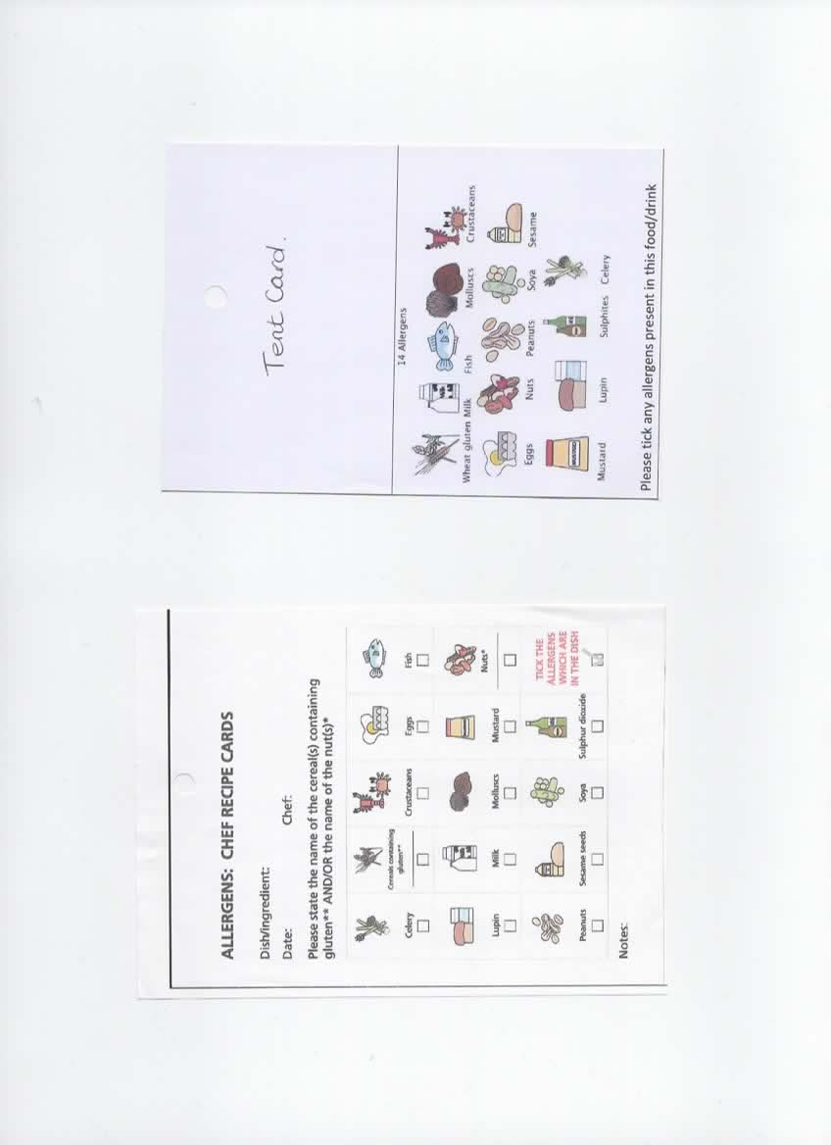

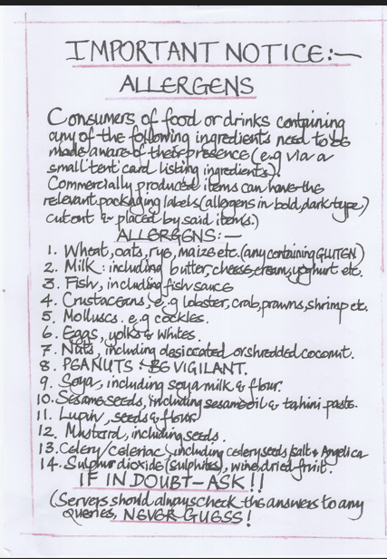
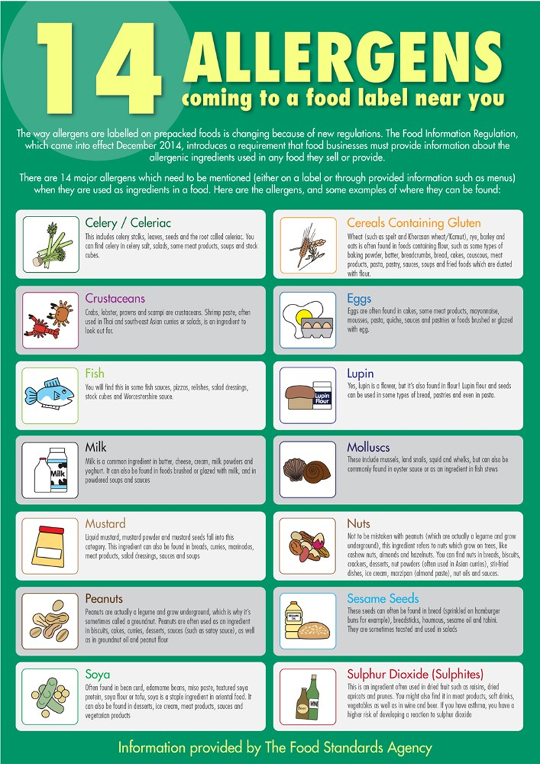

Allergens – KB v 5.1 Dec 2021 LW V5.2 Nov 23 Reviewed and Updated KB/LW June 26

