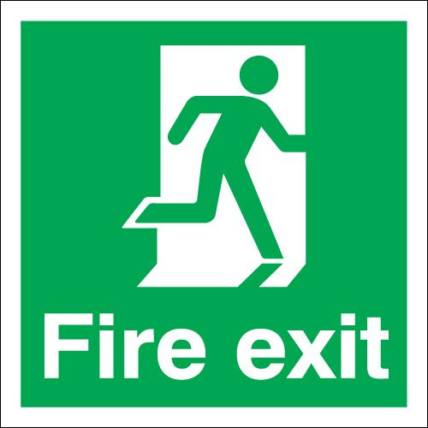
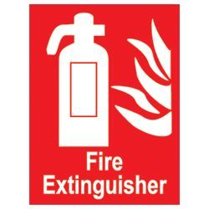

High Halden War Memorial Hall
Fire Safety
- Fire Risk Assessment – reviewed March 2026
- Evacuation Procedure
- Plan of hall showing fire exits, firefighting equipment and smoke detectors
- Fire extinguisher instructions, details of escape routes and assembly points.
- See also Testing schedule

Policy Reviewed – August 2020
March 2020 – Hall closed due to COVID. Insurance company advised and hall inspected at
least weekly by member of management committee.
August 2020 – kitchen has been cleared/gutted ready for refurbishment. Currently out of use.
April 2021 – Full review post project work and ahead of reopening
Nov 2023 – Full review of policy. Amendments to fire extinguishers
April 2025 – Minor Amendments. March 2026 – no changes

References
ACRE’s Village Hall Information Sheet 37 – Fire Safety in village halls – reviewed October 2015.

High Halden War Memorial Hall – FIRE RISK ASSESSMENT

The aims of this assessment are to:
- Identify the fire hazards
- Reduce the risk of those hazards causing harm to as low as reasonably practical
- Decide what physical fire precautions and management arrangements are necessary to ensure the safety of the people in the hall if a fire does start.
Identify the Fire Hazards – consider Ignition sources, fuel sources, oxygen sources
The following have been identified in the hall:
Ignition sources
- Kitchen area – oven, microwave, kettles, tea urns
- Various – electric sockets, electrical leads, 13 amp plugs
- Boiler
- Electrical equipment bought into hall and or used by hirers e.g. fans, craft equipment,
Fuel Sources
- Central Heating Oil
- Cleaning materials
- Foam, wooden tables,
- Curtains
- Cardboard and Paper (in store rooms and behind stage
- Building material in body of the hall e.g. wooden beams in ceiling.
- Dust in ceiling and higher parts of hall
- Equipment/tools/materials used by organisations including brownies, craft club, bowls club, table tennis
Sources of Oxygen
- Main hall
- Open windows and doors
WHERE THE ABOVE SOURCES COMBINE, THERE IS A RISK OF FIRE
Identify the People at Risk
- Hirers and users of the hall
- Cleaner who normally works alone
- Children - private events, brownies, events open to public, organisations events
- Disabled users and frail elderly users including wheel chair users and those reliant on walking frames.
Remove, Reduce and Protect
- Undertake regular inspections of electrical equipment
- Organise 5 yearly inspections of electrical systems
- Organise annual service of the boiler and fire extinguishers
- Review condition of the oil tank on a quarterly basis
- Foam (bowls club) and cushions to be stored away from ignition sources
- Arrange annual big clean including high level to eliminate dust build up
- Christmas and other decorations to be stored in designated storage areas away from Ignition sources.
- Craft/brownies/table tennis/short mat equipment and materials to be stored after each session in designated storage areas away from ignition sources.
- Candles must only be used with express permission of the management committee and then only in main hall. They must never be left unattended.
- Cleaning materials to be stored correctly with quantities stored in the hall kept to a minimum.
- Have in place regular testing process to include: emergency lighting, firefighting equipment, rechargeable torches, Emergency signs, exits and smoke detectors,
- Ensure that no cardboard, decorations or materials are kept/left in the boiler area.
Alarm
The hall does not have an alarm or siren to alert users to a fire/need to evacuate. However, as the hall is only on the ground floor with easy access to all rooms a shouted alarm should be adequate subject to the responsible adults in charge ensuring that toilets, the kitchen, the stage area and the large store cupboard (if being used) are checked if it is safe to do so.
Detectors
Detectors are connected to the mains in series and are sited as follows
Smoke detectors – corridor, lobby off main hall, stage
Heat detector – kitchen
Carbon detector – Boiler area
Escape Routes
Exit via the front door or emergency exit in the main hall allow easy access for all users including those in wheel chairs and should be used for evacuation whenever possible.
The fire door at the end of the corridor adjacent to the boiler room leads out onto a path at the end of the hall. To exit in a wheelchair or buggy requires a 90 degree turn onto a narrow path.
As the hall is all on the ground floor and with the majority of users only being in the main hall or toilet areas, helping frailer or disabled users including those in wheelchairs to exit via the main door or exit door in the main hall should be possible in virtually all situations.
Both of the emergency exits are operated by an exit bar which is 1.57m above the ground. They have been tested and adults should be able to operate them without problems. Smaller children would struggle but they will always be supervised by a number of responsible adults.

Assembly Points
Things to consider:
- Is the location a safe distance from the building?
- Is the space large enough for those using it?
- Is it possible to get safely to the assembly area?
- Is the layout and construction of the route to the assembly point, suitable and safe for those using it ?
- When deciding on the location of the assembly point, has consideration been given to the dangers from fire engines etc. arriving on the scene?
- Do emergency procedures ensure safety en route to the assembly point, e.g. when crossing traffic routes?

The agreed assembly area is the driveway of Beaulieu, the property next door to the hall. If this area is not safe the alternate assembly point will be the grass area at Hopes Grove.
Further action needed
Side fire escape – hedge leaning over making exit route tight. Need to cut back hedge and clear space. April 2021 Hedge replaced with fence leaving metre plus path. Ongoing need to keep path clear of weeds.

Reviewed by DH March 2026

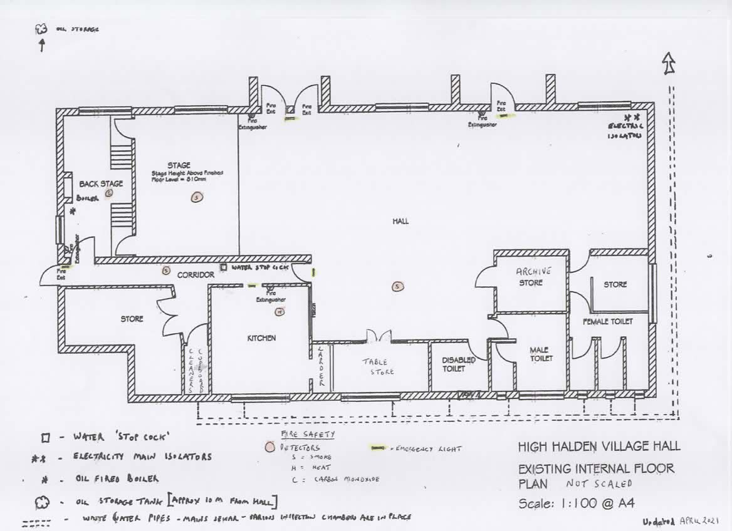

Plan of the hall as at April 2021

EVACUATION PROCEDURE

High Halden War Memorial Hall Evacuation Procedures If you discover a fire
- Take Command – give loud and clear instructions to immediately leave the hall and walk along the pavement in the Tenterden direction
- The hirer and/or a responsible adult should check the toilets, and kitchen (and stage area if this is being used) if they are safe to enter to ensure that everyone has left the building
- Close all internal doors if circumstances permit, as soon as the hall is empty
- Telephone the emergency services stating the following details: High Halden War Memorial Hall, Ashford Road, High Halden, TN26 3LY
- Try to tackle small fires with a fire extinguisher or the fire blanket, if it is appropriate to do so
- The hirer/responsible adult should brief the emergency services when they arrive particularly if there are any concerns that someone may still be in the hall
- Contact the Secretary on 01233 860335 or Treasurer 01233 850109
On being told there is a fire
- Leave the building immediately and walk along the pavement in the Tenterden direction
- Do not stop to collect belongings
- Assist others who may be more vulnerable than yourself
- Gather in the driveway of Beaulieu, the property next door, if it is safe to do so, otherwise walk to Hopes Grove and assemble on the grass area
version 1.8 Mar 26

Fire Extinguishers
Where are they situated? (See floor plan)
- 1 is just inside the main entrance door (on the right as you come into the hall) Foam filled
- 1 is on the inside front wall of the main hall next to the fire exit. Foam filled
- 1 is in the boiler room just inside the door as you enter the room. Powder filled for all purposes
- 1 is in the kitchen on the left as you enter. CO2 extinguisher filled with carbon dioxide and recommended for use on live electrical equipment.
- Fire Blanket – in the kitchen on the left as you enter. Effective for the immediate smothering of small fires.
How to operate the extinguishes
- Hold it upright
- Pull out the pin
- Aim at the base of the fire at a minimum distance of 1 metre
- Squeeze the lever
Maintenance
These are all subject to an annual maintenance agreement
ESCAPE ROUTES
Whenever possible leave using the main door in the hall out onto the car park/road.
If this is blocked leave by the fire exit in the main hall if possible or by the fire door at the end of the corridor next to the boiler room.

ASSEMBLY POINTS
When evacuating the hall everyone should leave the hall as quickly as possible and if it is safe to do so gather in the driveway of Beaulieu, the property next door, otherwise walk to Hopes Grove and assemble on the grass area

